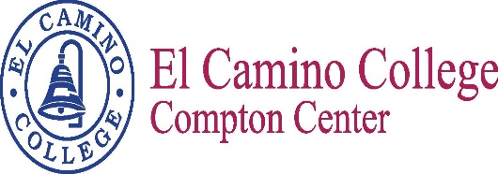
Name of meeting

Minutes
Meeting Date
Meeting Time

Vision
El Camino College Compton Center and the future Compton College will be the leading institution of student learning and success in higher education.

Mission Statement
El Camino College Compton Center and the future Compton College is a welcoming environment where the diversity of our students is supported to pursue and attain academic and professional excellence. Compton Center promotes solutions to challenges, utilizes the latest techniques for preparing the workforce and provides clear pathways for transfer, completion and lifelong learning.

Meeting Participants

Carmela Aguilar | Christine Aldrich | Nelly Alvarado | Richette Bell
Amber Gillis | Shateo Griffin | Elizabeth Martinez | Miguel Ornelas
Estina Pratt | Jessica Sanchez | Jose Villalobos | Aura Weber

Meeting Minutes

- Integrated SSSP/SEP/BSI plan
Discussed projects and funding. Some mentioned that it would be beneficial to see a breakdown on the funding.

- Leadership Conference – Highlights
Bailey is at a Conference with Dr. Subramaniam; however she provided copies of the Leadership
Conference, which is taking place on March 30, 2017. You are encouraged to attend as well as encourage students to attend. You can register through FLEX reporter.

- Conferences to SSSP/SEP/BSI
No update.

- Updates on Conferences attended or upcoming conferences
No update.

The Next Scheduled Meeting
March 23, 2017
1:00 p.m. / E38

