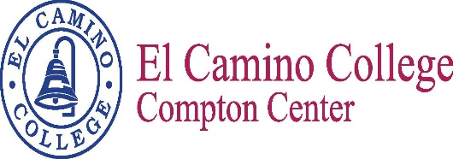

Student Success Committee

Facilitator: Dr. Jose Villalobos Recorder: Marina Hernandez

Date: February 23, 2017 Time: 1:00 p.m. Location: E38

Vision
El Camino College Compton Center and the future Compton College will be the leading institution of student learning and success in higher education.

Mission Statement
El Camino College Compton Center and the future Compton College is a welcoming environment where the diversity of our students is supported to pursue and attain academic and professional excellence. Compton Center promotes solutions to challenges, utilizes the latest techniques for preparing the workforce and provides clear pathways for transfer, completion and lifelong learning.

Members

Subramaniam, Chelvi | Villalobos, Jose | Aguilar, Carmela | Aldrich, Christine
Alvarado, Nelly | Bell, Richette | Bonacic, Trish | Edwards, Arnette
Ekimyan, Roza | French-Preston, Essie | Gillis, Amber | Griffin, Shateo
Haynes, Vanessa | Martinez, Elizabeth | Meadors, Joshua | Murray, Rodney
Ornelas, Miguel | Osanyinpeju, Abiodun | Perez, Barbara | Pratt, Estina
Sanchez, Jessica | Smith, Bailey | Weber, Aura

Agenda

Integrated SSSP/SEP/BSI plan
Include projects and Funding $

Leadership Conference – Highlights
March 30th

Conferences to SSSP/SEP/BSI
Updates on Conferences attended or upcoming conferences
The Next Scheduled Meeting
March 23, 2017
1:00 p.m./E38

