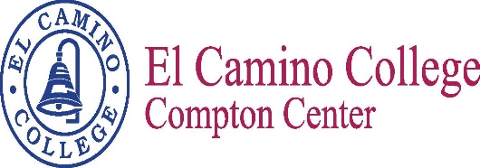

Name of meeting
Minutes
Meeting Date
Meeting Time

Vision
El Camino College Compton Center and the future Compton College will be the leading institution of student learning and success in higher education.

Mission Statement
El Camino College Compton Center and the future Compton College is a welcoming environment where the diversity of our students is supported to pursue and attain academic and professional excellence. Compton Center promotes solutions to challenges, utilizes the latest techniques for preparing the workforce and provides clear pathways for transfer, completion and lifelong learning.

Meeting Participants

Subramaniam, Chelvi | Pratt, Estina | Aguilar, Carmela
Smith, Bailey | Aldrich, Christine | Edwards, Arnette
Villalobos, Jose | Ornelas, Miguel | Martinez, Elizabeth

Meeting Minutes

- Update on HBCU Tour – Bailey Smith

39 students went on the HBCU tour of 7 colleges/historical sites. Got to participate in a
Homecoming game. Students were amazed by the experience. Had a number of students
follow-up with Dr. Edwards on the transferring process upon our return.

- Update on Student Equity Show Case – Bailey Smith

Bailey provided fliers and information on the Student Equity faculty showcase to get the
word out on a few of the projects and overall progress of the Student Equity Initiative.

- Update on SSSP activities – Nelly Alvarado

Nelly was not able to attend the meeting. Chelvi wanted some discussion on this item due
to the need to integrate all activities between SE & SSSP. There appears to be a lot of
information missing from the SSC Integrated Plan.

- BSI Update to Integrated Student Success Plan – Albert Jimenez

Albert was not in attendance to provide an update. Again, there appears to be a lot of
Information missing from the SSC Integrated Plan.

- Spring Semester meeting dates:
February 23, 2017
March 23, 2017
April 20, 2017
May 25, 2017
June 6, 2017

The Next Scheduled Meeting
February 23, 2017
1:00 p.m. / TBA

