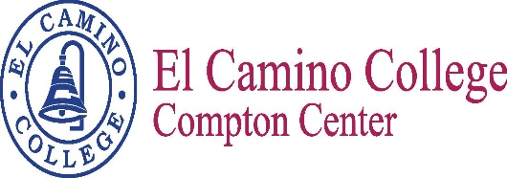

Student Success Committee
Minutes
October 27, 2016
1:00 p.m.

Vision
El Camino College Compton Center and the future Compton College will be the leading institution of student learning and success in higher education.

Mission Statement
El Camino College Compton Center and the future Compton College is a welcoming environment where the diversity of our students is supported to pursue and attain academic and professional excellence. Compton Center promotes solutions to challenges, utilizes the latest techniques for preparing the workforce and provides clear pathways for transfer, completion and lifelong learning.

Attendees

Pratt, Estina | Aguilar, Carmela | Weber, Aura
Davidson-Keller, Ginger | Sanchez, Jessica | Griffin, Shateo
Alvarado, Nelly | Smith, Bailey | Edwards, Arnette
Osanyinpeju, Abiodun | Aldrich, Christine | Ornelas, Miguel
Haynes, Vanessa | Villalobos, Jose

Meeting Minutes

Objective: SEP/SSSP Updates and SSC Plan Review

- Bailey Smith provided Student Equity projects updates. Implemented a number of projects that were approved in spring 2016 and the committee has recently approved many new projects. Currently have a few ongoing projects, including embedded tutoring, English SLA’s, EOP&S Care/Peer mentors and Math diagnostics. We are planning on moving forward with the Math DLA’s and the English Bridge for winter. Our HBCU tour is coming up in a couple weeks and we have 44 students scheduled for that tour.
- Nelly Alvarado and Shateo Griffin provided updates on SSSP. They are piloting a case management for Student Success to get students to complete assessment, orientation and abbreviated/comprehensive ed. plan. Students who have completed two full time semesters should have completed the ed. plan. Counselors are also doing short presentation called Grades Matter to let students know the importance of keeping their grades up and the consequences if they don’t.
- Albert was to provide a SSC Plan Review, however did not arrive until the end of the meeting. Estina Pratt and Nelly Alvarado provided information on their updated portions of the plan.

The Next Scheduled Meeting
December 1, 2016
1:00 p.m. / E38

