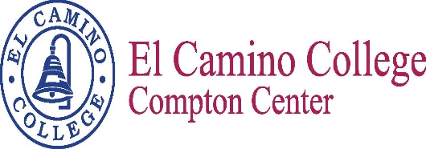

Committee / Meeting Name

Facilitator: Chelvi Subramaniam Recorder: Marina Hernandez

Date: September 8, 2016 Time: 1:00 p.m. Location: E38

Vision
El Camino College Compton Center and the future Compton College will be the leading institution of student learning and success in higher education.

Mission Statement
El Camino College Compton Center and the future Compton College is a welcoming environment where the diversity of our students is supported to pursue and attain academic and professional excellence. Compton Center promotes solutions to challenges, utilizes the latest techniques for preparing the workforce and provides clear pathways for transfer, completion and lifelong learning.

Attendees
Estina Pratt | Roza Ekimyan | Albert Jimenez
Nelly Alvarado | Jessica Sanchez | Miguel Ornelas
Bailey Smith | Arnette Edwards | Queen Juarez-Ward
Carmela Aguilar | Christine Aldrich | Elizabeth Martinez

Agenda

I. SEP/SSSP Summit 2016 – Albert Jimenez

II. HBCU 2016 tour – Bailey Smith

III. Updated Integrated Student Success Plan

IV. Other discussions

V. Tasks for the next meeting

The Next Scheduled Meeting
October 27, 2016
1:00 p.m. / E38

